Minutes of the 2nd internal project members meeting

|  |  |  |
| --- | --- | --- |
| **Date:** | **7 Dec 2022** |  |
| **Time:** | **21:00 – 21:30** |  |
| **Venue:** | **HPC1102** |  |
| **Present:** | Project team:  KWOK KA KIT (Scrum Master)  YIP KIN WANG (Technical Manager)  NG KA WAI Davina (Product Owner) | Client:  Ivy Wong |

Introduction:

Kick-off meeting with the client. Gather user requirements.

|  |  |  |
| --- | --- | --- |
| Item | Description | Target Completion Date |
| 1 | * Product Owner provided the highlights of meeting agenda as follows: * Project Plan * Sitemap * Discuss on Content Categorization * Discuss on the findings after research * Provide sample of ownership of copyright notice * Provide sample of privacy statement * Review on 1st web design layout * Review on the prepared content | Follow up by Project Team and provide solution in System Analysis and Design stage |
| 2 | * Technical Manager present the followings: - Content hierarchy   - Conceptual idea on System Design  - Conceptual idea on Database Design | Follow up by Project Team and provide solution in System Analysis and Design stage |
| 3 | * Scrum Master focus on the security issue: * Web authentication should adapt the W3C standard in order to create and use robust authentication credentials based on public key cryptography, it intends to define a web browser API. * Suggested below security flow: * A network security mechanism known as a DMZ (demilitarized zone) separates an organization's internal network from the Internet. By doing this, it reduces how vulnerable the internal network of a company is to dangers from the outside. * By putting the web server in the DMZ, the server is separated from the rest of the network and preventing an attacker from accessing confidential information on the internal network in the event that it is hacked. * The team continue study on GDPR Compliance Support. * The team continue study on data encryption during transition. | Follow up by Project Team and provide solution in System Analysis and Design stage |
| 4 | Client advised that the website should elaborate more on the security when public user submitting the bird record.   * Client spotted out current problem of the bird website as follows:   - Directory level structure was not user friendly.  - Some images located in the wrong order.   * Client commented on the website layout as follows:   - Colors and Font styles may need to be fine-tuned before project rollout.  - The project team may try to provide responsive design demonstration on next meeting.   * Client emphasis on ensuring appropriate security measures is implemented * Client suggested to subdivide web content review * Client provided further admin panel requirements | Follow up by Project Team and provide solution in System Analysis and Design stage |
| 5 | The meeting was adjourned at 21:30. | Nil |
| 6 | Coming Activities:   * The project team will study on the datasets from references website. * The client would like to have an update on project progress on the android app design. * The project team will present 2nd web design. * Next meeting with client will be Jan 12th 2022 | Nil |

Relevant ideas

1. Network Security Draft

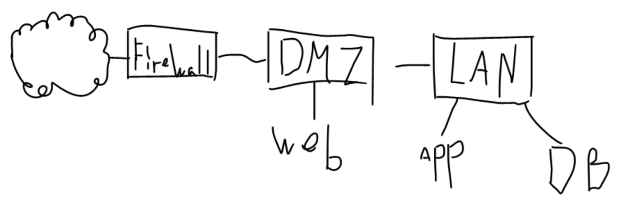

1. Website Draft

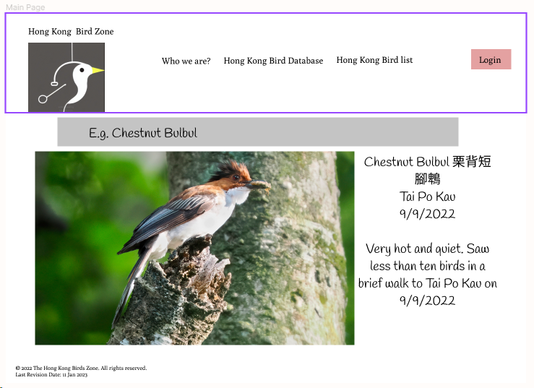

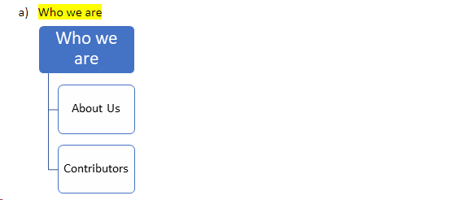

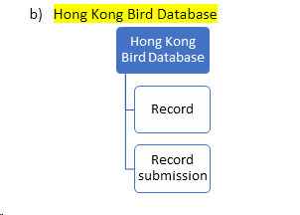

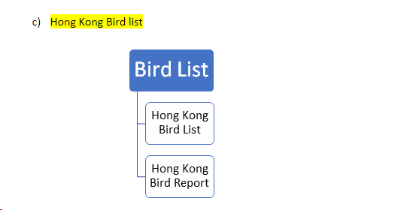

1. Data Base Table Draft

